Introduction
The global adoption of urban vertical farming and hydroponic systems has grown as a way to produce food in land-constrained environments. Vertical farming can produce food in a climate-resilient way with lower land and water use than conventional farming, but its success depends on efficient management, profitability, and energy efficiency (van Delden et al., 2021). As these systems expand upward across multi-tiered frames, however, keeping track of each growing position becomes an operational challenge. A lettuce farm in Iloilo, for example, had recorded its farm data by hand with inconsistent results (Domingo, 2022). Most technology support for hydroponics has come from Internet of Things (IoT) sensors that track temperature, humidity, pH, and nutrient levels (Dhanaraju et al., 2022; Santiago et al., 2025), but these sensors cannot tell a planted pot from an empty one, so checking pot occupancy still requires a visual inspection of the tower itself. Although YOLO-based models and UAVs have each been used in agriculture, the literature reviewed in Chapter 2 has not combined them into a low-cost system that inspects every pot on a vertical tower.
To address these monitoring challenges, this study introduces an autonomous drone inspection system integrated with computer vision and a centralized web dashboard. Each tower carries a printed sign with a QR code containing its ID, which the farmer scans with a smartphone to register the tower, while the phone saves its own GPS position as the location of the tower. The system then deploys a small drone equipped with an onboard camera that flies to the registered tower, aligns itself using the printed ArUco markers on the tower, and scans every face of the tower from bottom to top. While the drone is flying, the video is streamed to a ground laptop, where the YOLOv8 object detection model shows a live preview of the detected lettuce heads and empty pots. After landing, the full recording saved on the drone is processed to give the final count and match each detection to its exact pot on the tower. This automated visual inspection calculates slot availability for each tower, providing farm managers with clear spatial awareness without requiring manual tower walk-throughs. Because each tower is registered with its own QR code and location, a single drone can be sent to inspect many towers one after another, so the same hardware serves the whole farm rather than a single tower.
The system design focuses on practicality, affordability, and reliable performance. Instead of relying on expensive 3D sensors or complex spatial mapping techniques, the project uses standard two-dimensional video capture aimed directly at the vertical frame. Because the onboard Raspberry Pi companion computer has limited processing power, the heavy artificial intelligence processing is done on a ground laptop that receives the video over a local Wi-Fi network, while the Raspberry Pi handles only the light marker detection needed to steer the drone. Because the drone operates in an open, obstacle-free outdoor testing area, standard GPS, which is accurate only to a few meters, brings the drone near the tower, and the Raspberry Pi then uses the ArUco markers on the tower to keep a safe and steady distance while scanning. The ground laptop never steers the drone, so a weak or lost Wi-Fi link does not affect the flight.
All collected inspection data, such as images, timestamps, slot counts, and detection confidence levels, is first saved in a local offline cache on the ground laptop, so no internet connection is needed at the farm during the scan. This follows an offline-first design, which stores data locally first and synchronizes it when a connection is available (Mayta et al., 2026), and suits rural Philippine farms, where internet access remains uneven (Mirandilla-Santos, 2021; Serafica et al., 2023). The results are then uploaded to a central database and displayed on a web dashboard when the farmer chooses and an internet connection is available. Through the web dashboard, farmers can register hydroponic towers by scanning their QR codes, even without internet, since the registration is saved on the phone and uploaded later, request drone scans, and review historical crop occupancy records, while a local dashboard on the ground laptop lets them follow a scan live at the farm. By combining lightweight aerial robotics, accessible computer vision, and web-based monitoring, this project delivers a practical, low-cost solution for automated crop tracking in modern vertical hydroponic farming.
Furthermore, this automated monitoring system aligns with key United Nations Sustainable Development Goals (SDGs). Optimizing urban agriculture in land-constrained environments directly supports SDG 2 (Zero Hunger) and SDG 11 (Sustainable Cities and Communities). Additionally, integrating aerial robotics and computer vision advances SDG 9 (Industry, Innovation, and Infrastructure) by modernizing agricultural practices. Ultimately, improving the operational efficiency of hydroponic farms contributes to SDG 12 (Responsible Consumption and Production) through sustainable, resource-efficient food production.

REVIEW OF RELATED LITERATURE
The following literature and studies informed the design of the Computer Vision and Autonomous Drone Inspection for Hydroponic Towers with Web Dashboard Integration. The review moves from the agricultural problem to the technologies used to address it: vertical hydroponic farming and its monitoring challenges, IoT-based smart farming, QR codes and GPS tagging, computer vision for crop detection, object tracking for counting, unmanned aerial vehicles (UAVs) in agriculture, GPS limits and fiducial markers for drone positioning, edge versus offboard processing, offline-first data handling, web dashboards, 2D imaging versus 3D reconstruction, flight safety and regulations, and the development methodology and user evaluation. Each section combines foreign and local studies published within the last five years, together with current technical documentation, and relates them to the present study. The review closes with a synthesis and a statement of the research gap.

Vertical Hydroponic Farming and Its Monitoring Challenges
In a review of the current status of vertical farming, van Delden et al. (2021) reported that vertical farms can produce food in a climate-resilient manner with lower land and water use than conventional agriculture, but that their success in mainstream agriculture depends on improvements in profitability, energy efficiency, public policy, and consumer acceptance. Reviewing urban smart vertical farming in Malaysia, Saad, Hamdan, and Sarker (2021) argued that automation is needed to raise productivity, while Siregar, Seminar, Wahjuni, and Santosa (2022) identified the use of artificial intelligence to monitor crop growth and plant health as a main prospect of vertical farming. These reviews show that vertical systems suit land-constrained areas only when managed efficiently, yet they focus on environmental control and plant condition rather than on tracking which growing positions are in use.
Philippine initiatives follow a similar direction. DOST-PCAARRD (n.d.) reported that the University of the Philippines Los Baños developed the Sustainable Indoor Farm for Growing Leafy Vegetables using Artificial Lighting (SIGLA), a modular vertical farm for high-value leafy vegetables that included several lettuce cultivars in its trials. At a smaller scale, Bendanillo (2023) of Cebu Technological University described a hydroponic garden built from a PVC main line with holes for pots and a submersible pump that circulates the nutrient solution. This pipe-and-pot arrangement divides each structure into discrete growing slots, the same layout found in vertical hydroponic towers.
Monitoring these slots is still largely manual. Domingo (2022) reported that a lettuce farm in Iloilo recorded its microclimate and agronomic data by hand, producing inconsistent results and variable yields, until an Internet of Things (IoT) smart greenhouse developed by the Iloilo Science and Technology University reduced the labor involved. Petropoulou et al. (2023) showed that information on plant positions, obtained through imaging and computer vision, can guide how growing space is allocated in lettuce production. In Bohol, Bunga (2026) noted that many hydroponic systems still rely on manual monitoring and adjustment, which increases labor and delays responses to stress conditions, and reported that automation shifted the role of the operator from continuous monitoring to periodic supervision. Published studies, however, have rarely examined how long manual counts of planted and empty pots on vertical towers take or how accurate they are.
These findings justify the focus of the present study on slot availability, that is, the number of empty pots compared with the total number of slots on a tower, as information that farmers can use to plan replanting and harvesting.

IoT and Smart Farming in Hydroponics
Most technology support for hydroponic farms comes from the IoT, in which networked sensors collect and transmit farm data automatically. Dhanaraju, Chenniappan, Ramalingam, Pazhanivelan, and Kaliaperumal (2022) described smart farming as the progression of precision agriculture, in which real-time crop data and remote monitoring help farmers manage water and other resources more precisely. Locally, Domingo (2022) described an IoT system that automated the monitoring and control of growth parameters for lettuce grown in a nutrient film technique setup, while Santiago et al. (2025) of Manuel S. Enverga University Foundation developed an IoT system that monitored and regulated environmental conditions in real time and automated fertilizer delivery for lettuce in a community greenhouse.
These systems reduce the effort of maintaining growing conditions, but every one of them measured the air or the nutrient solution, and none reported whether each slot actually held a plant. A pH probe or temperature sensor cannot tell a planted pot from an empty one, so checking occupancy requires a visual record of the structure. The present study therefore adds a visual layer rather than replacing environmental monitoring. Instead of adding another electronic device to each tower, it identifies each tower with a printed QR code and records its location with the farmer's smartphone.

QR Codes, GPS Tagging, and Asset Registration in Agriculture
QR codes are widely used in agriculture to attach information to physical items. Qian, Xing, Zhang, and Yang (2021) studied the readability of QR codes on agro-food products scanned with mobile phones and found that reading distance, code size, and the curvature of the surface, together with their interactions, were the main factors affecting readability. Their results show that a QR code can reliably transfer an identifier to a phone in the field, provided that its size suits the reading distance.
Attaching a location to an asset depends on GPS accuracy. According to GPS.gov (n.d.), the accuracy a user obtains depends on satellite geometry, signal blockage, atmospheric conditions, and receiver quality; GPS-enabled smartphones are typically accurate to within a 4.9 m radius under open sky, and accuracy worsens near buildings, bridges, and trees. A GPS coordinate is therefore enough to locate a tower within a farm but not to identify a single pot. Averaging several readings from a stationary receiver reduces random scatter, but it cannot remove errors caused by obstructions or satellite geometry.
These sources support the design of the tower sign. A laminated sign on face A carries a printed QR code with the tower ID and a checksum, so that a phone can register the tower without manual typing, and the readability findings of Qian et al. (2021) guide the size and placement of the code. When the farmer scans the code, the phone records its own GPS position as the tower location. At an accuracy of about 4.9 m (GPS.gov, n.d.), this location is enough only to bring the drone to an approach point, and the final alignment is done visually. The same sign carries a large ArUco marker that helps the drone find the tower from the approach point and marks face A.

Computer Vision for Crop Detection
Most modern crop detection systems use convolutional neural networks (CNNs), which learn visual features from labeled images and output a bounding box and a class label for each object they find. In a review of the You Only Look Once (YOLO) family from its first version to YOLOv8, Terven, Córdova-Esparza, and Romero-González (2023) described YOLO as a central real-time object detection system for robotics and video monitoring and explained the standard evaluation metrics of precision, recall, and mean average precision (mAP). YOLOv8 was released in January 2023 with an anchor-free detection head designed to balance accuracy and speed for real-time tasks (Ultralytics, n.d.-a).
Wang, Wu, and Shen (2024) trained YOLOv8n on 2,240 frames from videos of hydroponic lettuce and reported precision and recall of around 99% in locating each lettuce head, and Petropoulou et al. (2023) used computer vision to monitor lettuce in an autonomous greenhouse. Both studies, however, focused on the plants themselves; neither treated an empty growing position as a class to be detected, and both worked with cameras and viewpoints far more stable than those of a moving drone.
Aerial images add difficulty because targets can appear small and partly hidden; Zhu and Chen (2026) observed that lightweight CNN detectors on UAVs struggle with small objects. A detector also learns only the classes and conditions in its labeled dataset, so images must be collected from the angles, distances, and lighting under which the model will be used.
These studies justify the choice of YOLOv8 for detecting lettuce and empty pots, and they establish precision, recall, and mAP@50 as appropriate measures of detection performance. The lack of an empty-pot class in previous lettuce studies is part of the gap the study addresses. The difficulties reported for aerial and small-object detection explain why the dataset is labeled in Supabox from multiple sides, distances, and lighting conditions and exported in YOLO format.

Object Tracking and Counting from Video
A detector running on every video frame sees the same lettuce head many times, so counting requires multi-object tracking, which links detections across frames and gives each physical object a single identity. Zhang et al. (2022) proposed ByteTrack, which associates every detection box with existing tracks instead of discarding low-confidence detections. Because low-score boxes are often partly occluded objects, keeping them reduces missed objects and fragmented trajectories, two common causes of miscounting.
Agricultural studies show that tracking quality strongly affects counting accuracy. Villacrés, Viscaino, Delpiano, Vougioukas, and Auat Cheein (2023) compared several tracking-by-detection algorithms for counting apples from orchard videos. With perfect detections, Multiple Hypothesis Tracking and DeepSORT reached multi-object tracking accuracies of 97% and 93%, respectively; when real deep learning detectors were used, DeepSORT obtained the lowest counting error, averaging 20.07% with YOLOv5 and 31.52% with Faster R-CNN. These findings show that a tracker cannot fully compensate for a weak detector, and that counting error should be measured against a manual ground truth rather than assumed from detection metrics alone.
Accordingly, ByteTrack runs on the ground laptop so that each pot is counted once as the drone climbs a face. The study goes further than the reviewed work by matching each tracked detection to a specific slot by face, level, and position using the marker positions, and by deciding the final status of a slot from all frames in which it appeared. Following Villacrés et al. (2023), the counting error per tower is computed by comparing the system counts with manual counts of lettuce and empty pots.

UAVs in Precision Agriculture and Greenhouse Inspection
UAVs are now common in precision agriculture, but mostly in open fields. In a survey of recent UAV studies, Aslan, Durdu, Sabanci, Ropelewska, and Gültekin (2022) observed that there were almost no UAV-based applications in greenhouses, where all-season crop production takes place. Close-range work near plants is also harder than mapping from altitude, because satellite positioning is not precise enough for near-ground flight (Andrzejewski et al., 2026).
Small, low-cost airframes make close-range work safer. De Azambuja, Fouad, Bouteiller, Sol, and Beltrame (2022) designed CogniFly, an open-source quadcopter under 250 g that combines carbon fiber or bamboo rods with 3D-printed soft joints; it survived multiple collisions at speeds of up to 7 m/s, flew for about 17 minutes without GPS, and had enough computing power to run deep neural network models on board. The present design takes its frame concept from CogniFly but differs in size, flight controller, and sensors.
Research drones of this kind usually run open-source autopilots. Aliane (2024) compared prominent open-source UAV autopilots in terms of hardware compatibility, software features, and communication protocols, including support for companion computers, the Robot Operating System, and software-in-the-loop (SITL) simulation, and listed ArduPilot as using the MAVLink protocol. ArduPilot documentation describes a companion computer as a small onboard computer that receives the MAVLink data produced by the autopilot, including GPS data, and uses it to make decisions during flight (ArduPilot Dev Team, n.d.-b), and explains how Gazebo can serve as an external simulator for ArduPilot Copter through SITL, including simulated camera video (ArduPilot Dev Team, n.d.-c).
These sources support the choice of a CogniFly-inspired micro-drone running ArduPilot on the SpeedyBee F405 Mini, with the Raspberry Pi Zero 2 W as a companion computer that exchanges MAVLink messages with the flight controller. They also support testing the full-tower scanning sequence in Gazebo with ArduPilot SITL before any real flight. The study does not perform obstacle avoidance; it limits flights to an open, obstacle-free area.

GPS Limitations and Visual Fiducial Markers for Drone Positioning
GPS alone cannot position a small drone precisely enough to inspect individual pots, since consumer receivers are typically accurate only to a few meters (GPS.gov, n.d.). Andrzejewski, Dziewoński, Kierzkowski, Szewczyk, and Kaliszuk (2026) described this as a positioning gap for precise near-ground flight and compared GNSS navigation with optical navigation based on ArUco and AprilTag markers on real small UAVs running ArduPilot. Across these studies, the common response to the limits of satellite positioning is to add a visual reference near the target.
Visual fiducial markers provide such a reference. A fiducial marker is a printed pattern with a known size and a unique ID that a camera can detect and use to compute its position relative to the marker. Kalaitzakis et al. (2021) compared ARTag, AprilTag, ArUco, and STag in terms of accuracy, detection rate, and computational cost under conditions that included shadows and motion blur, and concluded that fiducial markers can increase the accuracy and robustness of a localization system by providing an easily recognizable feature with embedded error detection. OpenCV documentation describes how ArUco markers are detected by thresholding the image, finding square contours, and reading the inner bits against a dictionary, and explains that the camera pose is then estimated from the four marker corners, which requires the camera matrix and distortion coefficients obtained from calibration (OpenCV, n.d.).
Most marker-based UAV studies have addressed precision landing. Andrzejewski et al. (2026) mounted a camera on a Raspberry Pi 5 companion computer that communicated with an ArduPilot flight controller over MAVLink 2 and compared touchdown precision under GPS and under optical navigation, confirming that a Raspberry Pi companion computer can detect markers and feed corrections to ArduPilot. Such studies, however, place markers flat on the ground below a descending drone, and their task ends with a single landing. Holding a constant distance from a vertical structure while climbing and moving around it, as tower scanning requires, is a different problem that the reviewed studies did not test.
The studies also suggest a division of roles between marker types. ArUco and AprilTag were designed for pose estimation (Kalaitzakis et al., 2021), while QR codes were designed to carry data and to be read by phones (Qian et al., 2021). A system that needs both identity and pose can therefore use a QR code to identify a structure and its reference face and use square fiducial markers for the geometric alignment.
This literature is the basis of the layered navigation used in the study. GPS waypoints bring the drone to an approach point, where the Raspberry Pi turns the drone slowly until it finds the large ArUco marker on the tower sign, then detects the smaller ArUco markers on each face and uses solvePnP to estimate its pose, sending small MAVLink velocity corrections several times per second in a position-based visual servoing loop. The camera is calibrated with a checkerboard pattern (OpenCV, n.d.). The QR code identifies the tower and face A, while ArUco markers at known positions on each face provide the pose and the slot reference. Extending marker-based alignment from landing pads to the vertical faces of a tower is part of the contribution of the study.

Edge Versus Offboard Processing and Live Video Streaming
Running deep learning models on small onboard computers is limited by heat as well as by speed. Shalash et al. (2026) benchmarked YOLOv8 to YOLOv12 on single-board computers, including the Raspberry Pi 4 and 5, and found that CPU-only execution remained insufficient for practical real-time deployment, with most configurations running below 3 frames per second; fans were installed on the boards to prevent thermal throttling. The smaller Raspberry Pi Zero 2 W was not tested, but as a weaker, passively cooled board it can be expected to perform worse under sustained detection in the sun.
An alternative is to send the video to a more capable computer on the ground. Zhu and Chen (2026) proposed a UAV architecture that switches between onboard processing and server-assisted processing; in their tests, communication over 5 GHz Wi-Fi had a latency of 15 to 45 ms depending on distance and interference, and frames were offloaded to the ground server only when the connection was strong. The same work shows the main weakness of offloading: when the link degrades, results arrive late or not at all. This suggests that time-critical control should stay on the drone, while heavier analysis can be done on the ground.
These findings support running YOLOv8, ByteTrack, and slot mapping on the ground laptop, which only watches and counts and never steers the drone, while all steering near the tower stays on the Raspberry Pi, which runs only light QR code and ArUco detection on reduced-resolution frames. Because Shalash et al. (2026) tested larger boards, thermal throttling is regarded as a likely risk for the Pi Zero 2 W rather than a demonstrated limit, so the frame rate of the marker detection and the temperature of the Pi are measured during testing. The latency reported by Zhu and Chen (2026) was measured over 5 GHz Wi-Fi, while the Raspberry Pi Zero 2 W supports only 2.4 GHz, which reaches farther but is more prone to interference; the delay of the actual link is therefore measured in this study rather than assumed. The same findings explain why close-range corrections are computed on the Pi instead of over Wi-Fi and makes stream delay and frame loss important performance measures, while a backup recording saved on the Pi covers frames lost when the link degrades.

Offline-First Systems and Connectivity in Rural Farms
Connectivity in the Philippines remains uneven. Using data from the National ICT Household Survey, Mirandilla-Santos (2021) reported that cellular signal reached 92% of surveyed barangays, that 3G technology was still prevalent in rural areas, and that urban barangays had about 10% more cellular coverage than rural ones. Serafica, Francisco, and Oren (2023) reviewed Philippine broadband policies and concluded that the implementation of government programs had been less than satisfactory, although satellite services have made connecting geographically isolated and disadvantaged areas more feasible. For a farm in a rural province, these findings mean that a reliable internet connection during field work cannot be assumed.
Offline-first design offers a way around this problem. Mayta, Boronda, and Montes (2026) built a mobile application for Andean farmers in Peru with an offline-first architecture for rural areas with limited connectivity and reported that it maintained a 100% synchronization rate under intermittent connectivity in controlled tests. Storing data locally first and synchronizing when a connection is available keeps a system usable when the server cannot be reached.
These sources support the use of an offline cache and a Sync Center in the present study. Tower registrations are saved first on the farmer's phone and scan results in a local SQLite database on the ground laptop. The scan itself needs only the drone, with the local Wi-Fi link used for the live preview, and the farmer chooses when to upload results to Supabase. The cache uses the same structure as the online database so that uploads can be repeated safely without creating duplicates.

Web Dashboards and Farm Management Information Systems
Farm data becomes useful only when growers can see and act on it. Surveying 280 German farmers, Schulze Schwering, Bergmann, and Sonntag (2022) found that the potential of farm management information systems (FMIS) as management tools is high but not yet fully exploited, and identified better compatibility, usability, and data security, along with more farm-specific features, as areas for improvement. Modern backend platforms make such dashboards easier to build: Supabase documentation describes a Realtime feature that lets an application listen for inserts, updates, and deletions in a PostgreSQL database as they happen (Supabase, n.d.). A relational database of this kind can represent the links between farms, towers, slots, and scan missions directly.
These sources support the use of Supabase (PostgreSQL) and a Next.js web dashboard as a small, farm-specific FMIS centered on tower records. The dashboard keeps the occupancy and inspection history of each tower, and the realtime feature lets the dashboard update when new scan results are uploaded. The map view built with Leaflet places each registered tower at the coordinates stored during QR code registration, which links the asset records to their physical locations.

Two-Dimensional Imaging Versus 3D LiDAR Reconstruction
Three-dimensional sensing provides geometry that two-dimensional images do not. Petropoulou et al. (2023) used 3D imaging to estimate lettuce growth and support plant spacing decisions, a task that depends on plant size and canopy shape. When the question is only whether a plant is present, however, two-dimensional RGB images have been sufficient: Wang et al. (2024) detected individual hydroponic lettuce heads from ordinary video frames with high precision and recall. Depth and LiDAR sensors also add weight, power demand, and processing load, which matter on a micro-drone whose total mass is around 200 to 240 g.
Because the task is only to classify each slot on the side of the tower facing the camera as occupied or empty, the study uses standard 2D RGB video from the Raspberry Pi Camera Module V2. Measurements of plant size, volume, or growth stage, which would justify 3D sensing, are outside the scope of the study.

Flight Safety, Wind Effects, and Drone Regulations
Wind is a major limit for small drones, since a lighter vehicle needs less wind force to be displaced. Meier, Hann, Skaloud, and Garreau (2022) proposed a dynamic model-based method that estimates wind from a multirotor's thrust and drag and tested it on flight data from a DJI Phantom 4; while hovering, it matched the precision and accuracy of existing methods that estimate wind from the drone's tilt, and it could also estimate wind while the drone was moving. Their work shows that a drone's own flight data can indicate when wind conditions are becoming unsafe.
Autopilot failsafes reduce the risk when conditions change. ArduPilot's battery failsafe can switch a copter to Return to Launch (RTL) or Land when the battery voltage stays below a set level for 10 seconds or the estimated remaining capacity falls below a threshold (ArduPilot Dev Team, n.d.-a). Drone operations are also regulated. The January 2026 edition of Part 11 of the Philippine Civil Aviation Regulations of the Civil Aviation Authority of the Philippines (CAAP) groups remotely piloted aircraft operations into open, specific, and certified categories. Operations in the low-risk open category need no special permit if the aircraft weighs 25 kg or less, is flown within visual line of sight, below 120 m above ground level, and in daylight, and is kept at least 30 m away from anyone not directly associated with its operation (CAAP, 2026).
These sources inform the safety design of the present study: tests are limited to fair weather and low wind, ArduPilot stabilization and GPS position hold are tuned with AutoTune, wind is checked with a handheld anemometer before each flight, and the drone returns to launch when the battery is low or the markers are lost for too long. The CAAP rules guide the choice of an open testing area away from people, supervised flights within sight of the pilot, and a manual RC override.

Development Methodology and User Evaluation
Rapid Application Development (RAD) builds information systems quickly through iterative prototyping and close user involvement rather than long, fixed planning. In a systematic review of RAD-based information systems, Fauzi et al. (2023) described RAD as a methodology often used by development teams that prioritize time efficiency and noted that it is considered to have the shortest completion time among software development life cycle models. The model is commonly organized into requirements planning, user design, rapid construction, and cutover, with the design and construction phases repeated until users accept the prototype. This cycle suits systems whose parts must be built and tested together several times before they work as a whole.
User evaluation of new systems often focuses on usefulness and ease of use. In a review of the questionnaires most used to evaluate mobile health applications, Hajesmaeel-Gohari, Khordastan, Fatehi, Samzadeh, and Bahaadinbeigy (2022) described the Technology Acceptance Model (TAM) questionnaire, which measures perceived usefulness and perceived ease of use, and the Usefulness, Satisfaction, and Ease of Use (USE) Questionnaire, whose 30 items cover usefulness, ease of use, ease of learning, and satisfaction on a seven-point Likert scale and correlate strongly with the System Usability Scale, supporting its validity. Reporting the weighted mean together with the standard deviation, and interpreting means through a fixed verbal scale, is a common way of summarizing such ratings.
These sources support the use of RAD in the present study, including the repeated cycle of user design and rapid construction before cutover. They also support evaluating the system in terms of usefulness, ease of use, and user satisfaction using an instrument based on the USE Questionnaire. Since the instrument uses a five-point scale and three categories instead of the original seven-point, four-section format, it is adapted from, rather than identical to, the USE Questionnaire (Hajesmaeel-Gohari et al., 2022), and its results are summarized using the weighted mean and standard deviation.

Synthesis
The reviewed literature agrees that vertical hydroponic farming can make better use of limited land, but only if it is managed efficiently (Saad et al., 2021; van Delden et al., 2021). Most technology support for hydroponics has taken the form of IoT systems that monitor the air and the nutrient solution (Dhanaraju et al., 2022), and Philippine projects have followed the same path (Domingo, 2022; Santiago et al., 2025). These systems reduce the work of maintaining growing conditions but do not record whether each pot holds a plant. At the same time, local farms still rely on manual observation, and the time and accuracy of manual slot counting have received little attention in published research.
Computer vision offers a way to fill this gap. YOLO detectors, and YOLOv8 in particular, have been shown to detect individual lettuce heads with high precision and recall (Terven et al., 2023; Wang et al., 2024), and multi-object trackers such as ByteTrack reduce double counting when the same plant appears in many frames (Villacrés et al., 2023; Zhang et al., 2022). Previous lettuce studies, however, detected plants rather than empty positions and used stable viewpoints. Detecting both occupied and empty slots from a moving camera, and linking each detection to a specific slot, has not been reported.
Bringing the camera to the tower is a positioning problem. Studies of agricultural UAVs have concentrated on open fields (Aslan et al., 2022), and GPS is accurate only to a few meters (GPS.gov, n.d.). Fiducial markers such as ArUco and AprilTag, combined with pose estimation, provide the missing precision (Kalaitzakis et al., 2021; OpenCV, n.d.), and recent studies have used them with Raspberry Pi companion computers and ArduPilot (Andrzejewski et al., 2026). These studies, however, used markers mainly for landing on horizontal pads rather than for holding position beside a vertical structure.
The literature on computing and connectivity points to a split design. Single-board computers struggle to run modern detectors in real time and need cooling to avoid throttling (Shalash et al., 2026), while offloading to a ground computer depends on the quality of the wireless link (Zhu & Chen, 2026). Philippine connectivity data show that a reliable internet connection cannot be assumed in rural farms (Mirandilla-Santos, 2021; Serafica et al., 2023), which favors offline-first designs that store data locally and synchronize later (Mayta et al., 2026). Finally, established measures of usefulness, ease of use, and satisfaction provide a basis for evaluating whether farmers would accept such a system (Hajesmaeel-Gohari et al., 2022).

Research Gap
The reviewed studies address parts of the problem but do not combine them. IoT studies monitor growing conditions but not pot occupancy; lettuce detection studies detect plants from fixed or stable viewpoints but not empty pots or slot positions; UAV studies in agriculture focus on fields and orchards rather than on individual vertical structures; and marker-based UAV studies focus on precision landing rather than on alignment with the faces of a tower. No reviewed study combined a low-cost micro-drone; QR code registration of each tower using the GPS of the farmer's phone; layered navigation that moves from GPS waypoints to onboard ArUco marker search and alignment; a full-tower, face-by-face scan that classifies every pot as occupied or empty and maps it to its slot; a live detection preview on a ground laptop with final counts computed from the full onboard recording; and an offline-first web dashboard designed for farms with intermittent internet. The present study addresses this gap by developing and evaluating such a system for vertical hydroponic towers holding lettuce, tested in an open outdoor area in the Philippine setting.
Objectives of the Study
This study aims to design and develop an autonomous drone-based monitoring system that registers vertical hydroponic towers through a printed QR code and the location of the farmer's phone, navigates to each tower using GPS, aligns itself using computer vision and visual markers, scans every face of the tower in an open space, detects lettuce plants and empty planting pots using computer vision, and displays tower-level records on a web-based dashboard.
The specific objectives of the study are:
- To identify the existing tools, process, and challenges in monitoring vertical hydroponic farming to establish the system's baseline requirements.
- To design and develop a web dashboard for QR-based tower registration using the location of the farmer's phone, scan requests, and inspection records that works even when the farm has no internet connection.
- To develop an autonomous navigation and alignment method that combines GPS waypoints with onboard QR code and ArUco marker positioning to scan every face of a tower.
- To develop a YOLOv8 computer vision model that detects lettuce heads and empty planting pots from the aerial video, shown as a live preview during flight and finalized from the full onboard recording after landing, and matches each detection to its exact pot on the tower, and to integrate it with the drone telemetry, offline cache, and web dashboard into a unified crop tracking system.
- To evaluate the system in terms of detection and counting accuracy, alignment and scan success, and its usefulness, ease of use, and user satisfaction.

Conceptual Framework
Figure 1 illustrates the flow of processes involved in registering, inspecting, and recording the planting status of vertical hydroponic towers through autonomous aerial scanning and computer vision. The figure shows how the tower sign, the farmer's smartphone, the drone, the ground laptop, the detection model, the database, and the web dashboard interact to give the farmer an updated count of occupied and empty pots for every registered tower. The numbered arrows show the order of the steps, where letters such as 5a and 5b mark parts of the same step, solid arrows show live flows, and dashed arrows show transfers that are done later, after landing or when an internet connection is available. The dotted outlines separate the parts that work offline over the local Wi-Fi network from those that need the internet.
Figure 1. Conceptual Framework of the Autonomous Hydroponic Tower Monitoring System
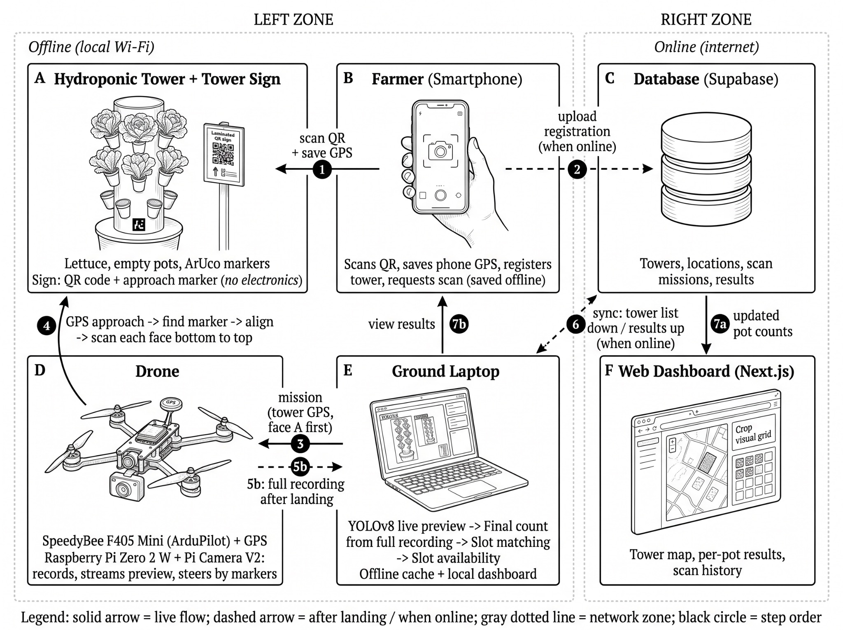
The operational workflow begins at the physical hydroponic tower. A laminated sign on face A carries a printed QR code with the tower ID and a checksum, together with a large ArUco approach marker. The farmer stands beside the tower and scans the QR code with a smartphone camera through the web application, which reads the code in the browser using the qr-scanner library and records the GPS position of the phone as the tower location (1). The registration and any scan request are saved on the phone and sent to the database once the phone has an internet connection (2). When an internet connection is available, the ground laptop downloads the list of registered towers and the scan requests from the database and keeps a copy, so that scans can be started from its local dashboard even without internet at the farm (6). Using the saved coordinates, the ground laptop sends the mission to the drone, which flies by GPS waypoint navigation to an approach point near the tower (3). From there, the Raspberry Pi on the drone turns the drone slowly until it finds the large approach marker, then uses the smaller ArUco markers on the tower to set the exact distance, height, and face. Starting from face A, the drone scans each face from bottom to top and moves around the tower to the next face until all faces are covered (4).
While the drone is scanning, a reduced-resolution video and the flight telemetry are streamed live over a local Wi-Fi network to the ground laptop (5a), where the trained YOLOv8 object detection model labels the lettuce heads and empty pots as a live preview on the local dashboard. After landing, the full recording saved on the drone is copied to the ground laptop (5b) and processed again to produce the final results, so frames lost during streaming do not affect the counts. The model classifies each pot as either occupied by a lettuce head or empty, and the positions of the markers are used to match each detection to its exact pot by face, level, and position. The final results are compiled to compute the slot availability of the tower and are saved in a local offline cache, together with timestamps and captured images. When the farmer chooses to upload the results from the Sync Center of the local dashboard and an internet connection is available, these records are sent to the central database (6), allowing the web dashboard to display updated inventory records, update historical logs, and provide exportable datasets for further research evaluation. The updated counts of lettuce and empty pots for each tower then reach the web dashboard (7a), where the farmer views the results on a smartphone or computer (7b).
The core of the drone is the SpeedyBee F405 Mini flight controller running ArduPilot (ArduCopter), which handles flight stabilization, altitude hold, GPS position hold, and waypoint missions with the help of the HGLRC M100-5883 GPS and compass module. A Raspberry Pi Zero 2 W serves as the companion computer. It records video through the Raspberry Pi Camera Module V2, saves a backup copy on its memory card, streams the video and telemetry to the ground laptop, and is the only computer that steers the drone near the tower, sending small position corrections to the flight controller based on the detected markers. The ground laptop runs the YOLOv8 model for the live preview and the final count but never sends flight commands, while Supabase and the Next.js web dashboard store and present the results. Running detection on the ground laptop keeps the onboard computer light and reduces the risk of thermal throttling during flight (Shalash et al., 2026).
Each block in the figure has a specific role. The hydroponic tower is the structural frame that holds the lettuce and empty pots and carries the printed ArUco markers at known positions on each face, which give the drone a fixed reference for its distance and height and allow each detection to be matched to a specific pot. The tower sign on face A identifies the tower through its QR code and helps the drone find the tower through its large ArUco marker; it has no electronics. The farmer's smartphone is used to scan the QR code and to send the tower registration and the scan request to the database. The drone and the ground laptop work as a pair during inspection: the drone flies the route, steers itself using the markers, and records the video, while the ground laptop interprets the video, matches each detection to its pot, computes the slot availability, and keeps the results in the local offline cache. The Supabase database stores the registered towers, their locations, the scan missions, and the detection results. The web dashboard, built with Next.js, presents the tower map, the per-pot results, and the scan history to the farmer. Finally, the two dotted outlines show the offline-first design of the system. Everything needed to fly and scan works on the local Wi-Fi network near the tower, and the internet is needed only to upload tower registrations from the phone, to download the tower list and scan requests, to upload the results, and to view them online.

Paradigm of the Study
The paradigm of the study follows the Input-Process-Output (IPO) model with a feedback loop. Figure 2 presents the inputs, the processes, including the methodology used to develop the system, and the expected output of the study.
Figure 2. Paradigm of the Study

▪ Technical Inputs
Drone, flight controller, GPS module, Raspberry Pi Zero 2 W, Pi camera, tower unit (ESP32 and e-paper QR display), ArUco markers, ground laptop, YOLOv8, ArduPilot, Supabase, and web dashboard
▪ Problem Input
▪ Related Literature Review

▪ Rapid Application Development (RAD)
◦ Requirements Planning
◦ User Design
◦ Rapid Construction
◦ Cutover
▪ Statistical Tool (Weighted Mean)
▪ Performance Metrics (Precision, Recall, mAP@50)
▪ User Evaluation Questionnaire

Computer Vision and Autonomous Drone Inspection for Hydroponic Towers with Web Dashboard Integration
INPUT
PROCESS
OUTPUT
FEEDBACK

As shown in the figure above, the paradigm of the study is divided into three parts. The input stage includes the problem input gathered through interviews with hydroponic farmers about how they currently monitor their towers, and the concepts and technical information gathered from related literature, which serve as the foundation of the system design. It also includes the technical inputs needed to build the system, namely the drone with its flight controller, GPS module, Raspberry Pi Zero 2 W, and camera, the printed tower sign with its QR code and approach marker, the ArUco markers, the ground laptop, and the main software tools YOLOv8, ArduPilot, Supabase, and the web dashboard.
The process stage represents the series of activities the researchers will carry out to transform the inputs into a working prototype. It follows the Rapid Application Development (RAD) model, which favors quick prototyping and repeated testing over long, fixed planning. In requirements planning, the researchers will gather the needs of the farmers and finalize the components, scope, and evaluation criteria. In user design, the researchers will design the system architecture, database, dashboard interface, and drone mission flow, and will test the full-tower scanning sequence in Gazebo before any actual flight. In rapid construction, the researchers will assemble the drone, the tower frame, and the tower sign, label the image dataset in Supabox, train the YOLOv8 model, develop the live streaming and visual alignment, and develop the web dashboard in short build and test cycles. In cutover, all components will be integrated and tested end to end in the open outdoor testing area. The process also includes the performance metrics used to test the system, namely precision, recall, and mAP@50 for the detection model, counting error for the lettuce and empty pot counts, and the alignment and scan success rate for the drone, as well as the statistical tool, the weighted mean, which will be used to interpret the ratings from the user evaluation questionnaire on the usefulness, ease of use, and user satisfaction of the system.
The output is the Computer Vision and Autonomous Drone Inspection for Hydroponic Towers with Web Dashboard Integration, a working system that reports lettuce counts, empty pot counts, and slot availability for each tower. The feedback loop returns the results of flight tests, detection tests, and user evaluations to the earlier stages so that the system can be refined in the next iteration.

Scope and Delimitation
This study focuses on the design, development, and evaluation of an autonomous drone inspection system that uses computer vision and a web dashboard to monitor vertical hydroponic towers. It covers the development of a working prototype that can register a tower by scanning a printed QR code with a smartphone that records the tower location, fly to the tower using its GPS coordinates, align with the tower using onboard detection of the QR code and ArUco markers, scan every face of the tower from bottom to top, detect lettuce heads and empty pots using a YOLOv8 model, with a live preview during flight and final counts after landing, and store and display the results on a web dashboard.
The scope includes the creation of a lettuce and empty pot image dataset annotated through Supabox, the training and testing of the detection model, and the computation of slot availability for each registered tower. The drone is a custom-built drone controlled by a SpeedyBee F405 Mini flight controller running ArduPilot, with a Raspberry Pi Zero 2 W and a Raspberry Pi Camera Module V2 for image capture. Each tower carries a laminated sign with a printed QR code and a large ArUco approach marker on face A, together with smaller printed ArUco markers on each face. During the flight, the Raspberry Pi streams the video and flight data over a local Wi-Fi network to a ground laptop, which shows a live detection preview, while the full recording saved on the drone is processed after landing to give the final count and match each detection to its pot on the tower. The results are kept in a local offline cache and are uploaded to a Supabase database and shown on a Next.js web dashboard when the farmer chooses to upload them. Through the web dashboard, farmers can register towers, view tower locations on a map, request scans, and review inspection history, while the local dashboard on the ground laptop lets them follow a scan live and upload cached scans. The evaluation covers detection and counting performance, slot matching accuracy, alignment and full-tower scan success, live streaming performance, flight time per tower, and the respondents’ assessment of the system’s usefulness, ease of use, and user satisfaction.
This study is limited to prototype-level testing on a physical structural frame, about 5 ft (1.5 m) tall and standing on a 3D-printed base, that holds lettuce and empty pots. The 5 ft height was chosen to fit the budget of the study, since each additional stackable module adds printing and material cost. Because the drone scans each face from bottom to top using markers at known positions, the same method is intended to extend to taller stacked towers and to many towers on one farm, but only one tower is built and tested in this study. The frame serves only as a visual target and does not include a working hydroponic watering or nutrient system. Lettuce is the only crop covered, so other leafy vegetables, fruit-bearing crops, and towers with mixed species are not included, and the results may not apply to other crop types. The detection model only classifies each slot as occupied by lettuce or empty. It does not assess plant diseases, pests, nutrient deficiencies, growth stage, or crop weight.
Flight operations are limited to an open, obstacle-free outdoor area where a GPS signal is available. Obstacle avoidance, indoor or greenhouse navigation, and flight in GPS-denied environments are not covered. Image capture uses standard two-dimensional RGB photos, so 3D LiDAR scanning and volumetric mapping of the crop canopy are not part of the study. The GPS location recorded by the farmer's phone is accurate only to a few meters, so it is used only to bring the drone near the tower, and the final alignment is done visually. The live preview requires the drone to stay within range of the local Wi-Fi network of the ground laptop, which the 20 m test radius is expected to satisfy, but no internet connection is needed during the scan. Because the drone steers itself, a lost Wi-Fi link does not stop the scan: the ground-station failsafe of ArduPilot is set so that losing the laptop link alone does not end the mission, the drone finishes the scan, and the final counts come from the onboard recording after landing. If the markers are lost, the drone holds its position for about 10 seconds, and if they are still not found, it returns to launch. Flight time is limited to about three to five minutes per battery because the study uses small, lightweight LiPo batteries to keep the drone light and low-cost, so each flight covers one tower. To keep the drone steady while scanning, the study relies on the built-in stabilization and GPS position hold of ArduPilot, together with the position corrections from the QR code and ArUco markers. Even with these corrections, the drone is very light and can still be pushed by strong wind, so flight tests will only be conducted in fair weather with sustained winds of [maximum wind speed, km/h] or less, measured on site with a handheld anemometer before each flight. If the wind rises above this limit, the operator cancels the scan and the drone returns to launch. All flights stay within a 20 m radius of the launch point and no higher than about 1.8 m (6 ft) above the ground, just above the top of the tower. Rain and night flights are not covered. Cellular connectivity, cloud GPU processing, and large-scale commercial deployment are outside the scope of this study.

Significance of the Study
Vertical hydroponic farming allows growers to produce more crops in less space, but keeping track of which pots are planted and which are empty becomes harder as towers grow taller and more numerous. This study is significant because it offers a low-cost way to automate this inspection by combining an autonomous drone, computer vision, and a web dashboard into one system. A farm usually has many towers, and stackable towers can be made taller by adding modules, so checking every pot by hand takes longer as the farm grows. One drone, however, can inspect all registered towers one by one and record the results in the same dashboard.
Hydroponic Farmers. The system can reduce the time and effort spent checking towers pot by pot across many towers, especially as towers are stacked higher and their upper levels become hard to see or reach. Updated counts of lettuce and empty pots can help farmers plan replanting, harvesting, and the use of their available space.
Farm Managers and Workers. The dashboard keeps a clear record of the occupancy and inspection history of each tower, which can lessen counting errors and make farm records easier to keep updated.
Students and Researchers. The study can serve as a reference for future work on drone-based crop monitoring and computer vision in agriculture. The labeled image dataset can also be used by future researchers who wish to study plant health, pest detection, or harvest readiness.
Academic Community. The study adds to the body of knowledge on smart farming, robotics, and applied computer vision, and shows how concepts in computer science can be applied to practical problems in local agriculture.
Local Community and Agricultural Offices. The findings may guide local agricultural offices and policymakers in promoting affordable technologies for urban and vertical farming, which supports food security and the efficient use of limited land.

Definition of Terms
The following terms are defined operationally according to their specific function, measurement, and implementation in this study:
ArUco Marker. A printed black-and-white square fiducial marker with a unique ID that a camera can detect quickly and use to estimate its position. In this study, ArUco markers are placed at known positions on each face of the tower so that the drone can compute its distance, height, and angle from the tower, and so that each detection can be matched to its exact pot.
Drone. The small unmanned aerial vehicle equipped with a flight controller, GPS module, Raspberry Pi, and camera, used to perform autonomous vertical scans of the towers in the testing area.
Empty Pot. A vacant growing slot on the tower that is detected by the model and counted as unused capacity.
Face. One side of the tower, made up of the vertical column of pots that points in one direction, together with the ArUco markers placed beside them. Because the tower is round, a face is not a flat surface but the side of the tower in front of the camera at each scanning position. Face A is the side that carries the tower sign and its QR code.
Occupied Pot. A growing slot on the tower that contains a lettuce head, detected by the model and counted as utilized capacity.
Slot Availability. The number of empty pots compared with the total number of slots on a tower, computed from the detection results of each scan.
Tower. The physical, multi-tiered structural frame, about 5 ft (1.5 m) tall, that holds lettuce and empty pots, carries ArUco markers and a tower sign, and serves as the target of the drone scan. It has no working watering system. Each tower has a unique ID and GPS coordinates.
Tower Sign. A laminated sign on a flat backing attached to face A of the tower, carrying a printed QR code with the tower ID and a checksum and a 15 × 15 cm ArUco approach marker. The farmer scans the QR code to register the tower, and the drone uses the approach marker to find the tower.
Vertical Scan. The flight maneuver in which the drone climbs along one face of the tower from bottom to top while recording video. In this study, the drone repeats the vertical scan on every face as it moves around the tower.
Web Dashboard. The web application used by farmers to register towers, view tower locations, request drone scans, follow a scan live, upload cached scans, and review inspection results and history.
YOLOv8. Stands for You Only Look Once version 8, a single-stage deep learning object detection model fine-tuned in this study to detect lettuce heads and empty pots in the captured images.

Research Methodology
The following are the research methods, procedures, and techniques that the researchers will use in developing the Computer Vision and Autonomous Drone Inspection for Hydroponic Towers with Web Dashboard Integration. These cover the research design, phases of the study, research environment, respondents of the study, research instruments, technology used, data gathering procedure, data treatment, and ethical considerations.

Research Design
This study uses a developmental research design with a mixed-method (qualitative and quantitative) approach, combined with the Rapid Application Development (RAD) model, which is often used by development teams that prioritize time efficiency through iterative prototyping and close user involvement (Fauzi et al., 2023). Qualitative data will be gathered through interviews with hydroponic farmers, while quantitative data will come from the performance tests of the system and the respondents’ ratings of its usefulness, ease of use, and user satisfaction.
Figure 3. Rapid Application Development Model
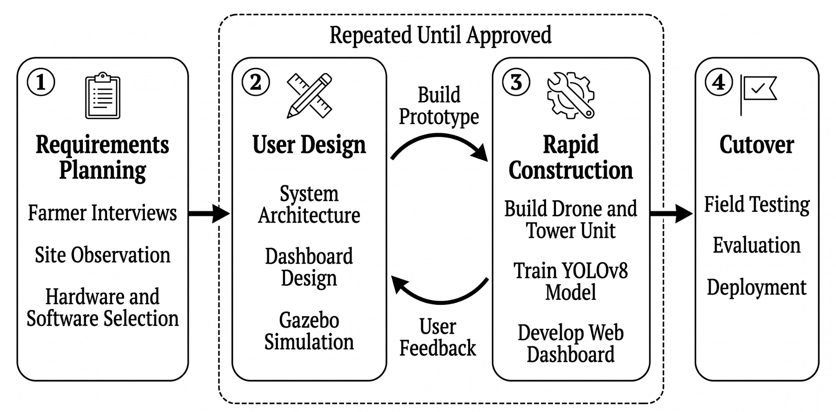
The researchers chose RAD because it focuses on building working prototypes quickly and improving them through repeated user feedback instead of following a long, fixed plan. This suits the study because the drone flight, the YOLOv8 model, and the web dashboard each need several rounds of building and testing before they can work together. The User Design and Rapid Construction phases are repeated as a cycle, so every working version of the system can be reviewed and refined before the final cutover.
Phases of the Study
Phase 1: Requirements Planning
The study begins by identifying how hydroponic farmers currently monitor their towers and what problems they face in tracking planted and empty pots. These needs will be gathered through interviews with hydroponic farmers using the interview questionnaire, including how often the farmers check their towers and how long each check takes, which serves as the baseline for comparing manual and automated inspection, together with a site observation sheet that records the tower type, height, number of levels, pots per level, open space in front of the towers, overhead obstructions, lighting and wind conditions, and the GPS and network signal near the towers. The findings will be supported by the review of related literature on vertical farming, computer vision, UAV-based inspection, and visual marker positioning presented in Chapter 2.
During this phase, the hardware and software components needed for the system are also identified and evaluated. These include the SpeedyBee F405 Mini flight controller running ArduPilot, the HGLRC M100-5883 GPS and compass module, the Raspberry Pi Zero 2 W companion computer, the Raspberry Pi Camera Module V2, brushless motors, LiPo batteries, the ground laptop, and the printed tower sign, along with the software tools YOLOv8, OpenCV, GStreamer, Supabox, Supabase, and Next.js. Each component is assessed based on availability, cost, weight, compatibility, and suitability for autonomous flight and image capture. The core functions of the system are then set as tower registration through a printed QR code and the location of the farmer's phone, GPS navigation to the tower, onboard visual alignment using the QR code and ArUco markers, scanning of every face of the tower, a live detection preview and final detection of lettuce and empty pots from the onboard recording, the matching of each detection to its pot on the tower, offline caching of scans, and the farmer-initiated upload of results to the web dashboard.
A SWOT analysis is conducted to support the prioritization of requirements. Figure 4 presents the strengths, weaknesses, opportunities, and threats of the proposed system.
Figure 4. SWOT Analysis
STRENGTHS | WEAKNESSES
• Automates the counting of lettuce and empty pots  • Uses a low-cost drone and 2D camera instead of LiDAR  • Scans all faces of the tower and identifies each pot  • Web dashboard with inspection history and a live scan preview  • Reduces manual inspection of tall towers  • Works offline; results can be uploaded later • Towers need only a printed sign, with no electronics | • Limited to lettuce only  • Short flight time due to small batteries  • Needs a GPS signal and an open space  • Live preview needs the laptop within Wi-Fi range  • Detection accuracy depends on the gathered dataset  • Pots without a visible marker are matched with lower confidence
OPPORTUNITIES | THREATS
• Saved images can be reused for plant health and harvest studies  • Can be extended to other crops and farm types  • Possible use of cellular and cloud processing for larger farms  • Possible collaboration with local farms and agricultural offices | • Strong wind and rain can affect flights  • GPS drift may cause misalignment with the tower  • Weak Wi-Fi signal may interrupt the live video stream  • Changes in lighting may reduce detection accuracy
Phase 2: User Design
This phase covers the design of the system based on the requirements gathered in Phase 1. The researchers will design the overall system architecture, the hardware and power connections of the drone, the layout of the tower sign and markers, the live flow of data from the drone to the ground laptop, the offline cache, and the online dashboard, the scan mission with its alignment and full-tower scanning process, the slot localization process, the database structure in Supabase, and the user interface of the Next.js web dashboard. Early versions of the dashboard screens will be presented to the target users, and their comments will be used to revise the design. The full-tower scanning sequence, including the movement around the tower and the response to lost markers and a lost Wi-Fi link, will also be tested in a Gazebo simulation with ArduPilot SITL before any actual flight.
The design follows three main decisions. First, the detection of lettuce and empty pots is done on the ground laptop and not on the Raspberry Pi Zero 2 W, since running YOLOv8 on its small processor would likely be slow and could cause thermal throttling during flight (Shalash et al., 2026). The Pi records the full video on its microSD card, streams a reduced-resolution copy and the flight telemetry over a local Wi-Fi network for the live preview, and runs only the light detection of the QR code and ArUco markers on frames of about 640 × 480 pixels at about 10 frames per second. Second, only the Pi steers the drone near the tower. GPS brings the drone to an approach point, the Pi turns the drone slowly until it finds the large ArUco marker on the tower sign, and the smaller markers then keep the drone at the correct distance, height, and face while it scans, with ArduPilot handling stabilization underneath. The ground laptop never sends flight commands, because the delay of a Wi-Fi link varies with distance and interference, and a late or lost correction near the tower could cause a collision. Third, the system works without the internet. Tower registrations are saved on the phone, the scan results are saved in a local offline cache on the ground laptop, and the final counts are computed from the full onboard recording after landing, so the farmer decides when to upload the processed scans to the online dashboard. If the Wi-Fi link is lost, the drone finishes the scan on its own; if the markers are lost, it holds its position for about 10 seconds and returns to launch if they are not found again; and if the RC link or the battery is lost, the ArduPilot failsafe returns it to launch.
System Overview
Before the detailed design figures, Figure 5 gives a visual overview of how the parts of the system work together in the field.
Figure 5. Conceptual Illustration of the System
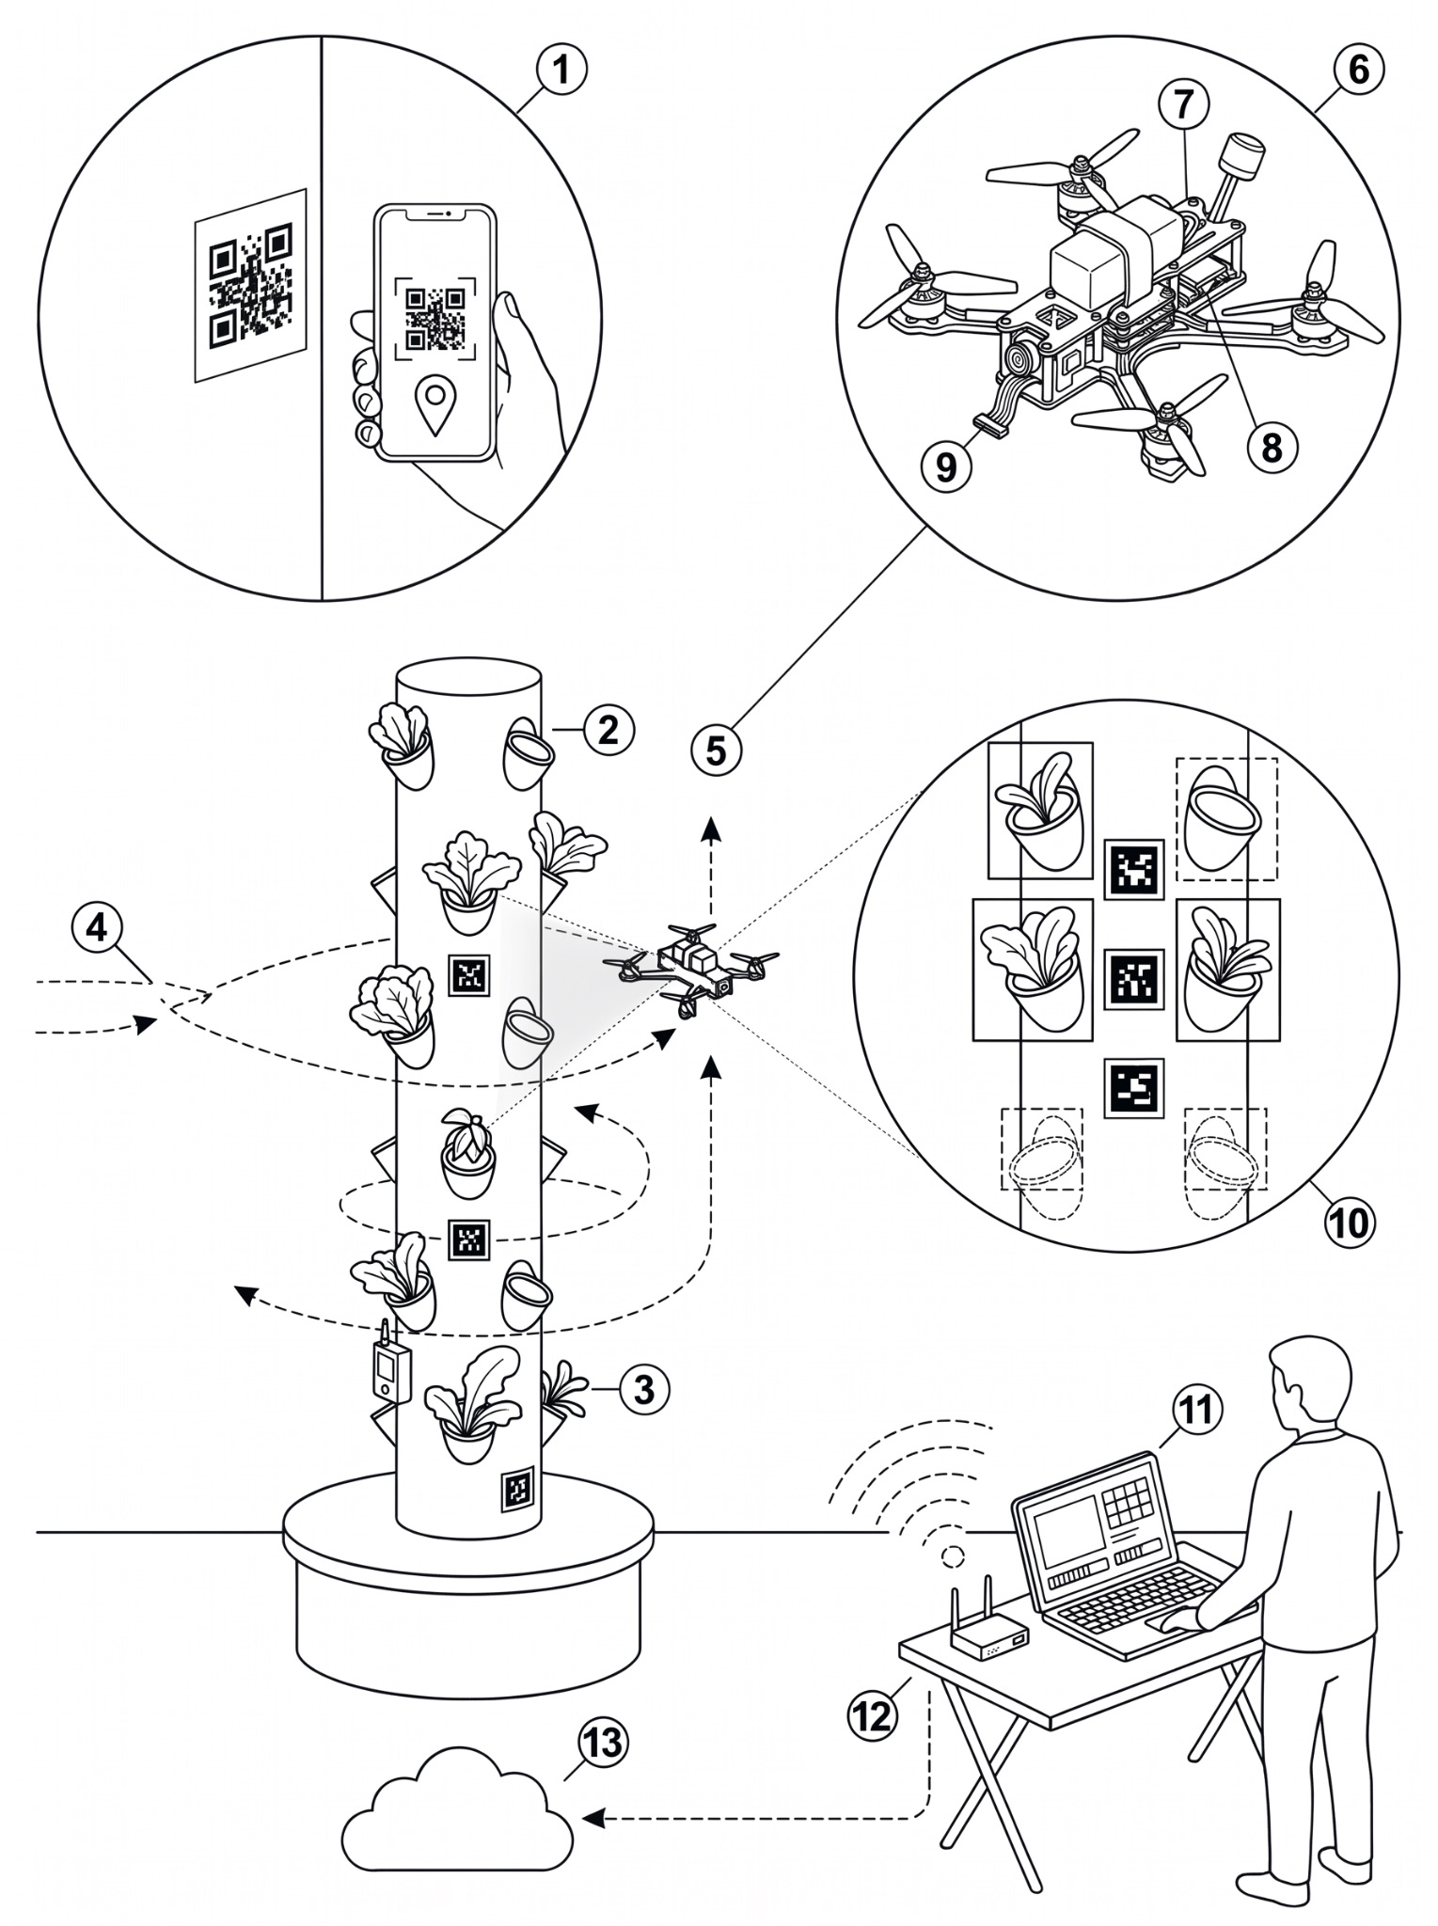
Figure 5 presents a conceptual illustration of how the system works in the field. The tower sign (1), a laminated board on face A with a printed QR code and a large ArUco approach marker, is scanned by the farmer with a smartphone through the web dashboard, which saves the GPS position of the phone as the tower location. The hydroponic tower frame (2), about 5 ft (1.5 m) tall and standing on a 3D-printed base, holds the lettuce and empty net pots, while ArUco markers are placed at known positions on each face (3). Using the saved coordinates, the drone follows a GPS approach path (4) to a point near the tower, finds the approach marker, aligns itself using the markers, and performs a vertical scan (5) of each face from bottom to top before moving around to the next face. The drone hardware (6) includes the HGLRC M100-5883 GPS and compass module (7), the SpeedyBee F405 Mini flight controller running ArduPilot together with the Raspberry Pi Zero 2 W companion computer (8), and the Raspberry Pi Camera Module V2 (9). In the live preview (10), YOLOv8 marks each lettuce head with a solid box and each empty pot with a dashed box, and the ArUco markers are used to match each detection to its pot. During the flight, the video is streamed to the ground laptop (11) over the local Wi-Fi network (12), where the detection model shows a live preview on the local dashboard; after landing, the full onboard recording is processed and the final results are saved in the offline cache, while the operator keeps the RC transmitter as a manual override. When the internet is available, the farmer uploads the saved results to the cloud (13), where Supabase stores them and the online web dashboard displays them.
System Design
Figure 6. System Design
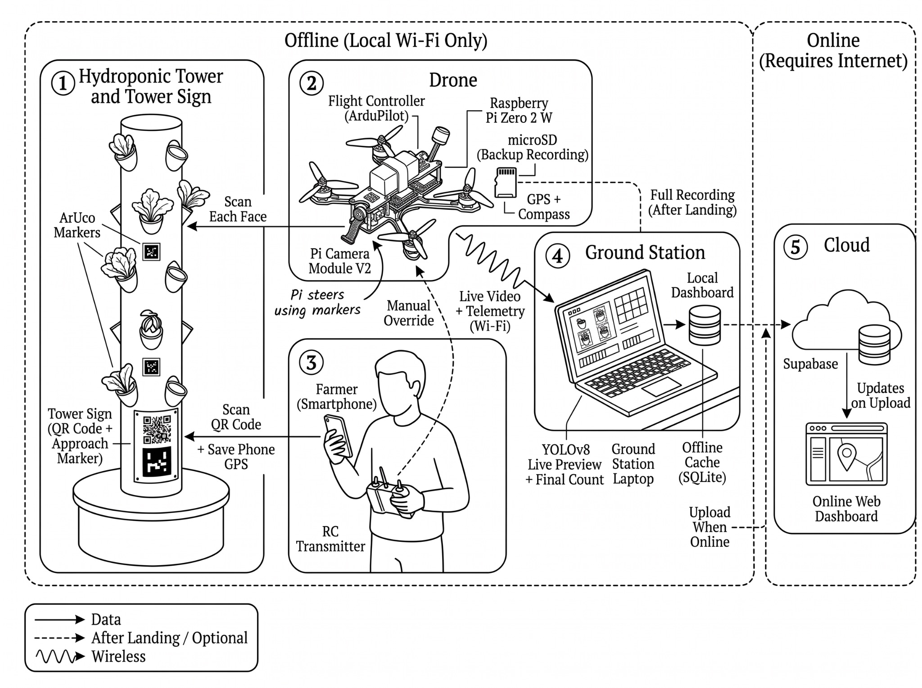
Figure 6 presents the overall design of the system, which is made up of five parts. The hydroponic tower and tower sign (1) hold the lettuce and empty pots, the ArUco markers on each face, and the laminated tower sign with the QR code and the large approach marker. The farmer (3) scans this QR code with a smartphone to register the tower and its location, while the RC transmitter is kept as a manual override for the drone. The drone (2) flies to the tower and scans each face using the Raspberry Pi Camera Module V2, while the Raspberry Pi Zero 2 W keeps it aligned using the markers and saves a backup recording on its microSD card. During the flight, the live video and telemetry are sent over local Wi-Fi to the ground station laptop (4), which runs YOLOv8 to show a live preview of the lettuce and empty pots on the local dashboard; after landing, the full recording is processed to give the final results, which are saved in the offline cache. Parts 1 to 4 work without the internet, and when the internet is available, the farmer uploads the results to Supabase in the cloud (5), where the online web dashboard updates as soon as the upload is received.
Technical Design
Figure 7. Technical Design
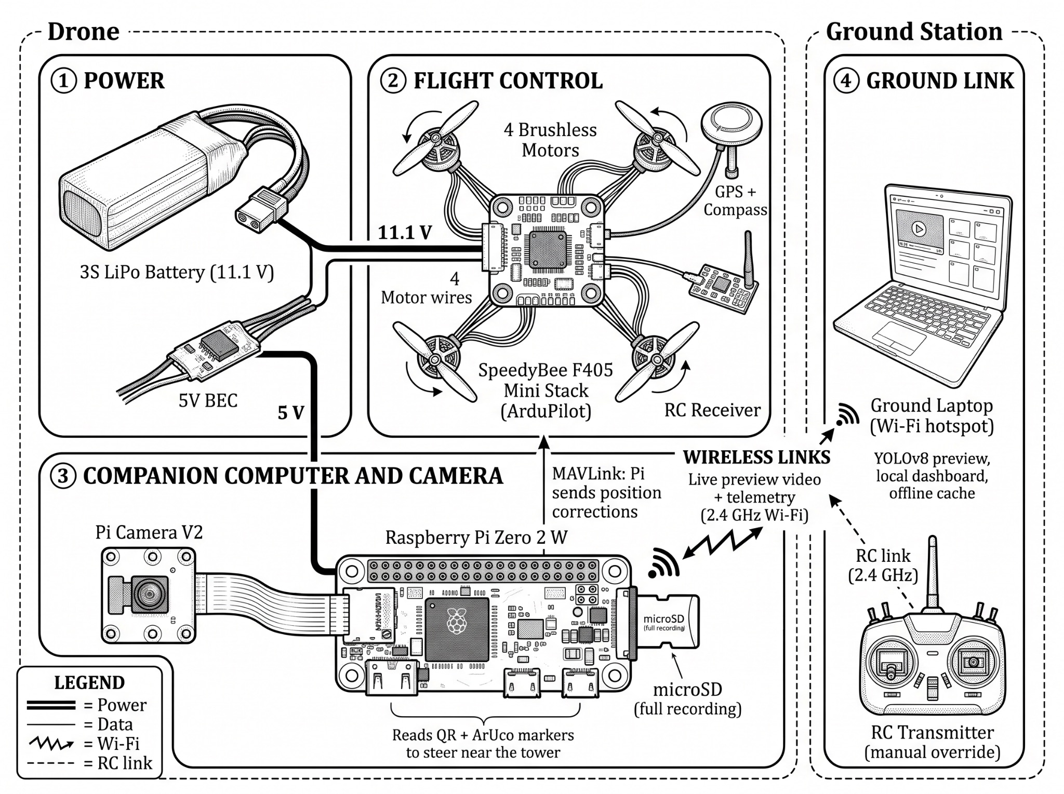
Figure 7 shows how the hardware of the system is connected, grouped into four parts. In the power system (1), the 3S LiPo battery powers the SpeedyBee F405 Mini stack directly, while a separate 5 V BEC powers the Raspberry Pi Zero 2 W so that sudden motor current does not restart it. In the flight control system (2), the flight controller runs ArduPilot, and its 4-in-1 ESC drives the four brushless motors in a Quad-X layout. The flight controller is also connected to the HGLRC M100-5883 GPS and compass module and to the RC receiver, and it handles stabilization, GPS position hold, waypoint missions, and failsafes such as return to launch when the RC signal or battery is lost.
In the companion computer and camera (3), the Raspberry Pi is connected to the flight controller through a serial link using the MAVLink protocol. Through this link, the Pi reads the position, altitude, and heading of the drone and sends small position corrections based on the detected markers; it is the only computer that sends flight commands. The Raspberry Pi Camera Module V2 records the scan as 1080p video, which is saved with the telemetry log on the microSD card as a backup. Through the ground link (4), the Pi streams the live video and telemetry over local Wi-Fi to the ground laptop, while the RC transmitter stays with the operator at all times as a manual override.
Phase 3: Rapid Construction
This phase involves building the actual prototype. The researchers will assemble the drone frame, motors, flight controller, GPS module, Raspberry Pi, and camera, and flash ArduPilot onto the flight controller. Based on the listed weights of the main parts, namely the 3S 650 mAh battery at about 55 to 60 g, the frame at about 50 to 70 g, the four motors at about 30 g, the flight controller stack at about 10 to 15 g, the Raspberry Pi Zero 2 W at about 11 g, and the GPS module, camera, receiver, regulator, propellers, and wiring at about 25 to 35 g, the estimated takeoff weight of the drone is about 200 to 240 g. The assembled drone will be weighed to confirm this before the first flight. A thrust and hover throttle test will then be done, and if the drone needs more than about half throttle to hover, the 1303 motors will be replaced with 1404 motors. ArduPilot AutoTune will then be run so that the flight controller is tuned to hold the drone steady in wind. The structural tower frame, about 5 ft (1.5 m) tall, will be built on a 3D-printed base and fitted with lettuce and empty net pots, and a laminated tower sign with the printed QR code and a 15 × 15 cm ArUco approach marker will be attached to face A on a flat backing. Images of the tower will be collected from multiple sides, distances, and lighting conditions, mostly as frames taken from drone and handheld videos at intervals of about one second so that nearly identical frames are not repeated. The researchers target about 2,000 labeled images, with at least 1,500 images containing each of the classes lettuce and empty pot. This follows Wang et al. (2024), who trained YOLOv8n on 2,240 frames of hydroponic lettuce, and the guideline of at least 1,500 images per class (Ultralytics, n.d.-b); the guideline of 10,000 labeled objects per class is treated as a goal for best results rather than a minimum. About 5% to 10% of the images will be background images that contain none of the classes, which helps reduce false detections (Ultralytics, n.d.-b). The images will be labeled in Supabox using the classes lettuce and empty pot, exported in YOLO format, and split into 70% training, 20% validation, and 10% testing sets, with all images from the same recording session kept in the same set so that the test images are truly unseen. The researchers will also calibrate the camera using a checkerboard pattern in OpenCV and attach laminated ArUco markers with unique IDs, mounted on small flat backings so that they stay flat on the round tower, at known positions along the height of each face of the tower. The marker detection on the Pi will first be bench-tested to confirm that it runs at about 10 frames per second without thermal throttling. At the same time, the live video stream from the Pi, the marker search and visual alignment on the Pi, the live preview and after-landing processing on the ground laptop, the offline registration on the phone, the local offline cache in SQLite, the Supabase database, the Next.js web dashboard, and the local dashboard on the ground laptop with its Live Scan view and Sync Center will be developed. Each part is built and tested in short cycles, and the researchers return to the User Design phase whenever a test shows that a change is needed.
Development is carried out in two stages. In the first stage, the researchers focus on the web dashboard, the tower sign, the image dataset, the Gazebo simulation, and the manual flight of the drone without the companion computer. In the second stage, the Raspberry Pi and camera are mounted on the drone, the GPS module is added, the visual alignment is tested, and the full pipeline from aerial capture and live streaming, to the live preview, after-landing processing, and offline cache on the ground laptop, to the upload and display of results on the dashboard is connected.
Hardware Components:
Table 1. Hardware Components
Hardware | Specification
Drone Frame | [Frame type and size, to be finalized], 3D-printable
Flight Controller and ESC | SpeedyBee F405 Mini Stack with BLS 35A 4-in-1 ESC, running ArduPilot (ArduCopter)
Motors | CADDXFPV 1303 6000KV 2-4S brushless motors (1404 motors, 3800 to 4600KV, if the thrust test fails)
Propellers | Gemfan Hurricane 3018, 2-blade [propeller size to match the final frame]
GPS Module | HGLRC M100-5883 GPS + Compass, mounted on a small mast
Companion Computer | Raspberry Pi Zero 2 W, quad-core ARM Cortex-A53
Camera | Raspberry Pi Camera Module V2 with Pi Zero ribbon cable, soft-mounted, recording at 1080p
Storage (Drone Cache) | microSD card, 32 GB, Class 10 / U1 / A1, for the backup recording
Tower Markers | Printed and laminated 6 × 6 cm ArUco markers (DICT_4X4_50) on small flat, rigid backings, with unique IDs, at known positions along the height of each face
Battery | LiPo 3S 11.1 V, 650 mAh, 75C, XT30
Voltage Regulator | 5 V regulator or BEC for the Raspberry Pi
Remote Control | RC transmitter and receiver, ExpressLRS (ELRS) 2.4 GHz, connected to the flight controller through CRSF
Ground Laptop | Laptop running Ubuntu 22.04 LTS
Tower Frame | Structural frame about 5 ft (1.5 m) tall, made of [frame material, e.g., 4 in PVC pipe], on a 3D-printed base, with [no. of faces] faces of [pots per face] lettuce and empty net pots each (no working watering system)
Tower Sign | Laminated sign on a flat rigid backing on face A, with a printed QR code (tower ID and checksum) and a 15 × 15 cm ArUco approach marker (DICT_4X4_50)
Local Wi-Fi | Ground laptop hotspot set to 2.4 GHz for the drone and ground laptop link, with a TP-Link TL-WR802N travel router as backup if range is insufficient

Software Components:
Table 2. Software Components
Software | Specification
ArduPilot (ArduCopter) | Flight control firmware
ROS 2 | Communication framework on the ground laptop
Python with OpenCV | Image processing on the Raspberry Pi and the ground laptop
YOLOv8 (Ultralytics) | Object detection model
Picamera2 | Video recording and H.264 encoding on the Raspberry Pi
GStreamer | Live video streaming from the Raspberry Pi to the ground laptop
pymavlink and mavlink-router | Telemetry, position corrections, and MAVLink forwarding
Ultralytics ByteTrack | Object tracking across video frames
OpenCV ArUco and QR detection | QR code and ArUco marker detection and camera pose estimation on the Raspberry Pi
SQLite | Local offline cache on the ground laptop
Supabox | Dataset annotation and YOLO format export
Gazebo Sim with ArduPilot SITL | Flight simulation
Supabase | PostgreSQL database, storage, and real-time updates
Next.js | Framework of the online web dashboard and the local dashboard on the ground laptop
qr-scanner (Nimiq) | Reads the tower QR code through the phone camera in the web dashboard
Leaflet with OpenStreetMap | Map display of tower locations
Ubuntu 22.04 LTS | Operating system of the ground laptop

Phase 4: Cutover
In this phase, the completed system is tested and deployed. The YOLOv8 model is tested on unseen tower images and evaluated using precision, recall, mean average precision (mAP), and the counting error per tower for lettuce and empty pots. The drone is tested through supervised outdoor flights in an open, obstacle-free area to measure the hover throttle and flight time per tower, the distance at which the QR code and ArUco markers can be read, the alignment error from the target distance and height, and the success rate of scanning every face of the tower. The accuracy of slot matching is checked by comparing the status assigned to each slot with the actual pot on the tower. The delay and the number of dropped frames of the live preview, the processing time per scan on the ground laptop, and the frame rate of the marker detection and the temperature of the Raspberry Pi during flight are recorded. The response of the drone is also tested when the Wi-Fi link is lost and when the markers are not visible. The offline cache and upload are tested by running scans without internet and uploading them later, including interrupted uploads, to check that no scan is lost or duplicated. The full workflow, from QR code registration to the display of results, is then tested end to end.
After testing, the system is presented to the respondents, who will use it and evaluate it in terms of usefulness, ease of use, and user satisfaction. Identified issues such as GPS drift, missed detections, or dropped video frames are documented, and recommendations for improvement are proposed. Final documentation is then prepared for the academic defense.

Research Environment
The study will be conducted at Purok 2, Busilac, Bayombong, Nueva Vizcaya, which provides an open, obstacle-free outdoor area with an available GPS signal for the flight tests of the drone. The site is selected because it allows safe drone operation and a clear view of the structural tower frame. The needs assessment interviews will be conducted with hydroponic farmers at Savara Lettuce Farm, located in Purok 5, Barangay Masoc, Bayombong, Nueva Vizcaya, Philippines. This farm is selected because it is the only hydroponic farm in Bayombong, Nueva Vizcaya.

Respondents of the Study
Table 3. Respondents of the Study
Respondents | Population | Total Enumeration
Hydroponic Farmers | 1 | 1
IT Experts | 3 | 3
Total | 4 | 4

The respondents of the study include hydroponic farmers, such as farm owners, farm managers, and farm workers, who will take part in the needs assessment interview and the evaluation of the system. IT experts from the College of Information Technology Education, Nueva Vizcaya State University, will also evaluate the system. Total enumeration is used because Savara Lettuce Farm is the only hydroponic farm in Bayombong, Nueva Vizcaya, and three (3) IT experts are available to evaluate the system. The respondents have direct experience in hydroponic farming or in system development.

Research Instruments
The researchers will use three instruments in this study. The first is an interview questionnaire for hydroponic farmers, which is divided into six parts: the respondent and farm profile, farm setup, current monitoring practices, monitoring challenges rated on a 5-point scale, views on the proposed system, and open-ended questions. The responses provide both qualitative and quantitative data on the needs of the farmers.
The second is a site observation sheet, which is filled in by the researchers on site to record the physical conditions of the towers and the area, such as the tower height, pots per level, open space for the drone, nearby obstacles, lighting, wind, and the GPS and signal strength. The third is a survey questionnaire adapted from the Usefulness, Satisfaction, and Ease of Use (USE) Questionnaire (Hajesmaeel-Gohari et al., 2022), which measures the usefulness, ease of use, and user satisfaction of the system. The original questionnaire has 30 items in four sections, namely usefulness, ease of use, ease of learning, and satisfaction, rated on a seven-point scale, so this study adapts it to a 5-point Likert scale from Strongly Disagree to Strongly Agree, using Moderately Agree instead of a neutral option so that respondents give a clear position on each item, with open-ended questions for further comments.

Technology Used
The system uses both hardware and software technologies to build a low-cost, autonomous, and reliable inspection system for hydroponic towers. Table 4 lists the software tools used in the system, their functions, and the layer of the tech stack where each is used, while Table 5 presents the cost of the hardware components and the benefit each provides to the system.
Software Components:
Table 4. Software Tools, Functions, and Tech Stack
Stack Layer | Software / Tool | Function
Drone Flight Control | ArduPilot (ArduCopter) | Flight controller firmware that handles stabilization, GPS position hold, waypoint missions, and failsafes such as return to launch
Drone Flight Control | [Ground control station, e.g., QGroundControl or Mission Planner] | Configures and calibrates ArduPilot, plans waypoint missions, and monitors telemetry
Drone Companion Computer | [Raspberry Pi OS Lite] | Operating system of the Raspberry Pi Zero 2 W
Drone Companion Computer | Picamera2 | Records video and encodes it in H.264 on the Raspberry Pi
Drone Companion Computer | GStreamer | Streams the live video from the Raspberry Pi to the ground laptop
Drone Companion Computer | pymavlink and mavlink-router | Send position corrections to the flight controller and forward MAVLink telemetry
Drone Companion Computer | OpenCV ArUco and QR detection | Reads the QR code and ArUco markers and estimates the camera pose so that the Raspberry Pi can steer the drone near the tower
Ground Processing | Ubuntu 22.04 LTS | Operating system of the ground laptop
Ground Processing | ROS 2 | Connects the processing modules on the ground laptop
Ground Processing | Python with OpenCV | Main programming language and image processing library
Ground Processing | YOLOv8 (Ultralytics) | Detects lettuce and empty pots in the video frames for the live preview and the final count
Ground Processing | Ultralytics ByteTrack | Tracks detected objects across frames so each pot is counted once
Ground Processing | SQLite | Stores scan results in a local offline cache until internet is available
Model Development | Supabox | Annotates the image dataset and exports it in YOLO format
Simulation | Gazebo Sim with ArduPilot SITL | Tests flight missions in simulation before real flights
Cloud Back End | Supabase | Provides the PostgreSQL database, file storage, and real-time updates
Web Front End | Next.js | Framework of the online web dashboard and the local dashboard on the ground laptop
Web Front End | qr-scanner (Nimiq) | Opens the phone camera in the web dashboard and reads the tower QR code so the farmer can register the tower without typing
Web Front End | Leaflet with OpenStreetMap | Shows tower locations on a map

The tech stack of the system is organized by layer, as shown in Table 4. The drone runs ArduPilot on the flight controller, while the Raspberry Pi Zero 2 W records and streams the video, detects the markers, and is the only computer that sends position corrections through MAVLink. The ground laptop runs Python, OpenCV, YOLOv8, and ByteTrack on Ubuntu with ROS 2, and keeps results in SQLite while offline. Supabase serves as the cloud back end, and the web dashboard is built with Next.js and Leaflet.
Cost and Benefits:
Table 5. Cost and Benefits
Component | Specification | Purpose | Qty | Price (PHP)
Drone Frame | [Frame type and size, to be finalized] | Holds the drone components | 1 | 800 to 1,200
Flight Controller Stack | SpeedyBee F405 Mini with BLS 35A 4-in-1 ESC | Flight control and motor driving | 1 | 5,342
Brushless Motors | CADDXFPV 1303 6000KV 2-4S (1404 if the thrust test fails) | Generate thrust | 4 | 3,609.07
Propellers | Gemfan Hurricane 3018, 2-blade | Generate lift | 4 pairs | 168.15
Companion Computer | Raspberry Pi Zero 2 W | Image capture, live streaming, and visual alignment | 1 | 2,000 (est.)
Camera | Raspberry Pi Camera Module V2 | Captures tower images | 1 | 2,299
Camera Ribbon Cable | Pi Zero camera cable | Connects camera to the Pi | 1 | 80 to 200 (est.)
microSD Card | [32 GB or higher], Class 10 / A1 | Drone Cache for video and telemetry | 1 | 350 (est.)
GPS + Compass | HGLRC M100-5883 | GPS navigation and heading | 1 | 1,050
LiPo Battery | 3S 11.1 V, 650 mAh, 75C, XT30 | Powers the drone | 3 | 1,005
LiPo Charger | LiPo battery charger | Charges the batteries | 1 | 625
Voltage Regulator | 5 V regulator or BEC | Powers the Raspberry Pi | 1 | 609
RC Transmitter and Receiver | RC control link | Manual control and safety override | 1 | 3,850 (est.)
TPU 95A Filament | 1 kg spool | Protective frame parts | 1 | 700 to 1,200 (est.)
PLA or ABS Filament | 1 kg spool | Rigid plates | 1 | 600 to 1,000 (est.)
Screws and Standoffs | M2 screws, nuts, standoffs, rubber rings | Mounting of parts | 1 set | 150 to 500 (est.)
Tower Sign | Printed QR code and 15 × 15 cm ArUco approach marker, laminated, on a flat rigid backing | Tower registration and drone approach | 1 | 150 (est.)
ArUco Markers | Printed and laminated, 6 × 6 cm, on flat rigid backing, DICT_4X4_50 | Visual alignment and slot matching | 20 (16 + 4 spares) | 500 (est.)
Tower Frame | [Frame material, e.g., 4 in PVC pipe], about 5 ft (1.5 m) tall | Main body of the tower and visual target of the drone | 1 | 800 to 1,000 (est.)
Tower Base | 3D-printed base (already printed) | Keeps the tower upright and stable | 1 | Included in PLA filament
Net Pots | 2 in plastic net pots (can also be 3D-printed) | Serve as the occupied and empty slots of the tower | 16 (est.) | 50 to 160 (est.)
Lettuce Plants | Live hydroponic lettuce heads, replaced when they wilt | Occupy the slots for detection | 10 (est.) | 400 to 850 (est.)
Local Wi-Fi Router | Ground laptop hotspot (2.4 GHz); TP-Link TL-WR802N travel router only if flight tests show poor range | Drone and laptop Wi-Fi link | 1 | 0 (uses ground laptop); about 1,000 to 1,500 if the router is needed
Handheld Anemometer | Digital handheld wind meter | Pre-flight wind check | 1 | 500 to 800 (est.)
ESTIMATED TOTAL |  |  |  | 25,637 to 28,467

The estimated total excludes the ground laptop, which the researchers already own, and the set of four 1404 motors, which will be bought only if the thrust test fails and would add an estimated 3,000 to 4,000 PHP. The tower base is 3D-printed from the PLA filament listed above, so it adds no separate cost. Each tower needs only a printed and laminated sign instead of an electronic unit, which keeps the cost of adding more towers low.
In terms of benefits, the system replaces the manual, pot-by-pot inspection of tall towers with an automated drone scan, which reduces the time and effort of monitoring and the need to climb or reach the upper levels. Most of the components are low-cost, off-the-shelf, or 3D-printed, and the software tools are free and open source, which keeps the system affordable for small hydroponic farms. The printed tower signs and markers cost little and are reusable across scans, and the offline cache allows the system to be used even in farms with weak internet connection.

Data Gathering Procedure
After the interview questionnaire is finalized, it will be submitted to the thesis adviser for suggestions and approval. A letter of request will be prepared, and the required approvals from the appropriate school authorities and the farm owners will be secured. The primary mode of data collection will be face-to-face interviews conducted by the researchers, which allow direct interaction and the clarification of responses when needed. Each interview takes about 15 minutes.
A preliminary interview with the owner of Savara Lettuce Farm was conducted on October 11, 2026, using the interview questionnaire and with the respondent's informed consent. Its results will be included in the needs analysis in Phase 1.
Before each interview, the respondents will be informed of the purpose of the study and their role in it, and their informed consent will be obtained. With their permission, the interview may be audio-recorded for note-taking, and photos of the towers, without people, may be taken for the study. While on site, the researchers will also fill in the site observation sheet. Images of the towers gathered during the visits and the tests will be added to the dataset in Supabox.
After the development of the system, the researchers will conduct test flights and detection tests in the testing area and record the results. The respondents will then be shown how to use the system and will answer the USE Questionnaire to evaluate it.

Data Treatment
After the data are collected, they will be organized, categorized, and analyzed to describe the needs of the farmers and the performance of the system.
For the qualitative data, the researchers will read through the interview notes and transcripts, code the responses, and group them into themes related to current monitoring practices, challenges, and the views of the farmers on drone monitoring. The results of the needs analysis will also be used to update the SWOT analysis.
For the system performance, the YOLOv8 model will be evaluated using precision, recall, and mean average precision (mAP@50), while the counting accuracy will be measured by comparing the counts of the system with manual counts of lettuce and empty pots on each tower. The flight tests will be measured by the rate of successful alignments, the mean alignment error in centimeters, the rate of completed full-tower scans, the slot matching accuracy, the average delay and frame loss of the live stream, and the flight time per tower.
For the quantitative data from the USE Questionnaire, the researchers will use descriptive statistics, specifically the weighted mean and standard deviation. The analysis will be organized by the three categories of the tool, which are usefulness, ease of use, and user satisfaction. The weighted mean will show the average rating of the respondents for each category, while the standard deviation will show how similar or varied the responses are. The computed means will be interpreted using the scale in Table 6.
Table 6. Interpretation of the Level of Usefulness, Ease of Use, and User Satisfaction
Scale | Range | Descriptor | Interpretation
5 | 4.21 to 5.00 | Strongly Agree | Highly Acceptable
4 | 3.41 to 4.20 | Agree | Acceptable
3 | 2.61 to 3.40 | Moderately Agree | Moderately Acceptable
2 | 1.81 to 2.60 | Disagree | Not Acceptable
1 | 1.00 to 1.80 | Strongly Disagree | Highly Not Acceptable

Ethical Considerations
The researchers will observe ethical standards throughout the conduct of the study to protect the rights and well-being of the respondents. Participation is voluntary, and the respondents may skip questions or stop at any time. All information will be kept confidential in accordance with the Data Privacy Act of 2012 (Republic Act No. 10173), and the respondents and their farms will remain anonymous unless they give permission to be named. Audio recordings and photos will only be taken with consent, and photos will only show the towers and not people.
For safety, all drone flights will be supervised, conducted in an open area away from people, and done only in fair weather, with a manual RC override ready at all times, and the drone will return to launch when the battery is low or the markers cannot be found, while the operator cancels the scan if the wind rises above the set limit. The researchers will also follow Part 11 of the Philippine Civil Aviation Regulations (CAAP, 2026). Because the drone weighs about 200 to 240 g and is flown within visual line of sight, no higher than about 1.8 m above the ground, and only in daylight, its flights fall under the open category, which does not require a special permit. Anyone not directly involved in the operation will be kept at least 30 m away. During the user evaluation, the respondents take part as directly involved participants: they stay with the researchers at the ground station, start scans only from the dashboard, and do not handle the RC transmitter, which stays with a trained researcher at all times.
The researchers used AI tools for assistance during the study. All AI-generated outputs were reviewed and verified by the researchers to ensure accuracy and academic integrity. No sensitive or personal data of the respondents were shared with AI tools, and all decisions and interpretations remained under human supervision.

References
Aliane, N. (2024). A survey of open-source UAV autopilots. Electronics, 13(23), 4785. https://doi.org/10.3390/electronics13234785
Andrzejewski, K., Dziewoński, B., Kierzkowski, A., Szewczyk, M., & Kaliszuk, K. (2026). Experimental evaluation of precision positioning in unmanned aerial systems using fiducial markers. Electronics, 15(8), 1582. https://doi.org/10.3390/electronics15081582
ArduPilot Dev Team. (n.d.-a). Battery failsafe. ArduPilot Copter documentation. Retrieved October 14, 2026, from https://ardupilot.org/copter/docs/failsafe-battery.html
ArduPilot Dev Team. (n.d.-b). Companion computers. ArduPilot Dev documentation. Retrieved October 14, 2026, from https://ardupilot.org/dev/docs/companion-computers.html
ArduPilot Dev Team. (n.d.-c). Using SITL with Gazebo. ArduPilot Dev documentation. Retrieved October 14, 2026, from https://ardupilot.org/dev/docs/sitl-with-gazebo.html
Aslan, M. F., Durdu, A., Sabanci, K., Ropelewska, E., & Gültekin, S. S. (2022). A comprehensive survey of the recent studies with UAV for precision agriculture in open fields and greenhouses. Applied Sciences, 12(3), 1047. https://doi.org/10.3390/app12031047
Bendanillo, A. (2023). A review of the integration of hydroponic agricultural gardening in urban areas and construction technology towards sustainability. International Journal of Arts, Sciences and Education, 4(3). https://ijase.org/index.php/ijase/article/view/267
Bunga, A. J. M. (2026). IoT-based hydroponic greenhouse with automated environmental control and machine learning-assisted nutrient optimization. Engineering Proceedings, 163(1), 13. https://doi.org/10.3390/engproc2026163013
Civil Aviation Authority of the Philippines. (2026). Philippine civil aviation regulations Part 11: Aerial work and operating limitations for non-type certificated aircraft (January 2026 ed.). https://www.caap.gov.ph/wp-content/uploads/2026/01/PART-11-Aerial-Work-and-Operating-Limitations-for-Non-Type-Certificated-Aircraft.pdf
de Azambuja, R., Fouad, H., Bouteiller, Y., Sol, C., & Beltrame, G. (2022). When being soft makes you tough: A collision-resilient quadcopter inspired by arthropods’ exoskeletons. In 2022 IEEE International Conference on Robotics and Automation (ICRA) (pp. 7854–7860). IEEE. https://doi.org/10.1109/ICRA46639.2022.9811841
Dhanaraju, M., Chenniappan, P., Ramalingam, K., Pazhanivelan, S., & Kaliaperumal, R. (2022). Smart farming: Internet of Things (IoT)-based sustainable agriculture. Agriculture, 12(10), 1745. https://doi.org/10.3390/agriculture12101745
Domingo, O. F. (2022, January 7). IoT-smart greenhouse hydroponics for lettuce makes its way to farm enterprise. DOST-PCAARRD. https://pcaarrd.dost.gov.ph/index.php/quick-information-dispatch-qid-articles/iot-smart-greenhouse-hydroponics-for-lettuce-makes-its-way-to-farm-enterprise
DOST-PCAARRD. (n.d.). DOST-PCAARRD, UPLB research on indoor farming opens opportunities for the industry. https://www.pcaarrd.dost.gov.ph/index.php/quick-information-dispatch-qid-articles/dost-pcaarrd-uplb-research-on-indoor-farming-opens-opportunities-for-the-industry
Fauzi, M. A., Tribiakto, H., Moniva, A., Amir, F., Ilyas, I. K., & Utami, E. (2023). Systematic literature reviews on rapid application development information system. Bulletin of Computer Science and Electrical Engineering, 4(1), 57–64. https://doi.org/10.25008/bcsee.v4i1.1181
GPS.gov. (n.d.). GPS accuracy. Retrieved October 14, 2026, from https://www.gps.gov/systems/gps/performance/accuracy/
Hajesmaeel-Gohari, S., Khordastan, F., Fatehi, F., Samzadeh, H., & Bahaadinbeigy, K. (2022). The most used questionnaires for evaluating satisfaction, usability, acceptance, and quality outcomes of mobile health. BMC Medical Informatics and Decision Making, 22, Article 22. https://doi.org/10.1186/s12911-022-01764-2
Kalaitzakis, M., Cain, B., Carroll, S., Ambrosi, A., Whitehead, C., & Vitzilaios, N. (2021). Fiducial markers for pose estimation: Overview, applications and experimental comparison of the ARTag, AprilTag, ArUco and STag markers. Journal of Intelligent & Robotic Systems, 101(4), Article 71. https://doi.org/10.1007/s10846-020-01307-9
Mayta, J., Boronda, A., & Montes, J. (2026). Design of a mobile application with a hybrid recommendation system for connecting Andean farmers and urban consumers in Peru. International Journal of Advanced Computer Science and Applications, 17(9), 785–793. https://thesai.org/Downloads/Volume17No9/Paper_74-Design_of_a_Mobile_Application.pdf
Meier, K., Hann, R., Skaloud, J., & Garreau, A. (2022). Wind estimation with multirotor UAVs. Atmosphere, 13(4), 551. https://doi.org/10.3390/atmos13040551
Mirandilla-Santos, M. G. (2021). Bridging the digital infrastructure gap: Policy options for connecting Filipinos (PIDS Policy Note No. 2021-07). Philippine Institute for Development Studies. https://doi.org/10.62986/pn2021.07
OpenCV. (n.d.). Detection of ArUco markers. OpenCV documentation. Retrieved October 14, 2026, from https://docs.opencv.org/4.13.0/d5/dae/tutorial_aruco_detection.html
Petropoulou, A. S., van Marrewijk, B., de Zwart, F., Elings, A., Bijlaard, M., van Daalen, T., Jansen, G., & Hemming, S. (2023). Lettuce production in intelligent greenhouses—3D imaging and computer vision for plant spacing decisions. Sensors, 23(6), 2929. https://doi.org/10.3390/s23062929
Qian, J., Xing, B., Zhang, B., & Yang, H. (2021). Optimizing QR code readability for curved agro-food packages using response surface methodology to improve mobile phone-based traceability. Food Packaging and Shelf Life, 28, 100638. https://doi.org/10.1016/j.fpsl.2021.100638
Saad, M. H. M., Hamdan, N. M., & Sarker, M. R. (2021). State of the art of urban smart vertical farming automation system: Advanced topologies, issues and recommendations. Electronics, 10(12), 1422. https://doi.org/10.3390/electronics10121422
Santiago, Y. C., Forbes, E., Sial, I. M., Santonil, H. S. P., Canela, D. N., & Maaño, R. C. (2025). IoT-based monitoring and automatic fertilizer for Olmetie lettuce growth in greenhouse environments. IOP Conference Series: Earth and Environmental Science, 1572, Article 012020. https://doi.org/10.1088/1755-1315/1572/1/012020
Schulze Schwering, D., Bergmann, L., & Sonntag, W. I. (2022). How to encourage farmers to digitize? A study on user typologies and motivations of farm management information systems. Computers and Electronics in Agriculture, 199, 107133. https://doi.org/10.1016/j.compag.2022.107133
Serafica, R. B., Francisco, K. A., & Oren, Q. C. A. (2023). Making broadband universal: A review of Philippine policies and strategies (PIDS Discussion Paper Series No. 2023-31). Philippine Institute for Development Studies. https://doi.org/10.62986/dp2023.31
Shalash, O., Khatab, E., El-Agamy, A., Elmokadem, L., Abouelsaad, Y., Zaki, J., El-Sayed, M., & Said, H. (2026). Benchmarking YOLOv8–YOLOv12 for real-time object detection on single-board computers. Machine Learning and Knowledge Extraction, 8(7), 204. https://doi.org/10.3390/make8070204
Siregar, R. R. A., Seminar, K. B., Wahjuni, S., & Santosa, E. (2022). Vertical farming perspectives in support of precision agriculture using artificial intelligence: A review. Computers, 11(9), 135. https://doi.org/10.3390/computers11090135
Supabase. (n.d.). Postgres changes. Supabase documentation. Retrieved October 14, 2026, from https://supabase.com/docs/guides/realtime/postgres-changes
Terven, J., Córdova-Esparza, D.-M., & Romero-González, J.-A. (2023). A comprehensive review of YOLO architectures in computer vision: From YOLOv1 to YOLOv8 and YOLO-NAS. Machine Learning and Knowledge Extraction, 5(4), 1680–1716. https://doi.org/10.3390/make5040083
van Delden, S. H., SharathKumar, M., Butturini, M., Graamans, L. J. A., Heuvelink, E., Kacira, M., Kaiser, E., Klamer, R. S., Klerkx, L., Kootstra, G., Loeber, A., Schouten, R. E., Stanghellini, C., van Ieperen, W., Verdonk, J. C., Vialet-Chabrand, S., Woltering, E. J., van de Zedde, R., Zhang, Y., & Marcelis, L. F. M. (2021). Current status and future challenges in implementing and upscaling vertical farming systems. Nature Food, 2(12), 944–956. https://doi.org/10.1038/s43016-021-00402-w
Villacrés, J., Viscaino, M., Delpiano, J., Vougioukas, S., & Auat Cheein, F. (2023). Apple orchard production estimation using deep learning strategies: A comparison of tracking-by-detection algorithms. Computers and Electronics in Agriculture, 204, 107513. https://doi.org/10.1016/j.compag.2022.107513
Wang, Y., Wu, M., & Shen, Y. (2024). Identifying the growth status of hydroponic lettuce based on YOLO-EfficientNet. Plants, 13(3), 372. https://doi.org/10.3390/plants13030372
Zhang, Y., Sun, P., Jiang, Y., Yu, D., Weng, F., Yuan, Z., Luo, P., Liu, W., & Wang, X. (2022). ByteTrack: Multi-object tracking by associating every detection box. In S. Avidan, G. Brostow, M. Cissé, G. M. Farinella, & T. Hassner (Eds.), Computer Vision – ECCV 2022 (Lecture Notes in Computer Science, Vol. 13682, pp. 1–21). Springer. https://doi.org/10.1007/978-3-031-20047-2_1
Ultralytics. (n.d.-a). Ultralytics YOLOv8. Ultralytics documentation. Retrieved October 28, 2026, from https://docs.ultralytics.com/models/yolov8/
Ultralytics. (n.d.-b). Tips for best YOLOv5 training results. Ultralytics documentation. Retrieved October 28, 2026, from https://docs.ultralytics.com/yolov5/tutorials/tips-for-best-training-results
Ultralytics. (n.d.). Explore Ultralytics YOLOv8. Ultralytics documentation. Retrieved October 14, 2026, from https://docs.ultralytics.com/models/yolov8
van Delden, S. H., SharathKumar, M., Butturini, M., Graamans, L. J. A., Heuvelink, E., Kacira, M., Kaiser, E., Klamer, R. S., Klerkx, L., Kootstra, G., Loeber, A., Schouten, R. E., Stanghellini, C., van Ieperen, W., Verdonk, J. C., Vialet-Chabrand, S., Woltering, E. J., van de Zedde, R., Zhang, Y., & Marcelis, L. F. M. (2021). Current status and future challenges in implementing and upscaling vertical farming systems. Nature Food, 2(12), 944–956. https://doi.org/10.1038/s43016-021-00402-w
Villacrés, J., Viscaino, M., Delpiano, J., Vougioukas, S., & Auat Cheein, F. (2023). Apple orchard production estimation using deep learning strategies: A comparison of tracking-by-detection algorithms. Computers and Electronics in Agriculture, 204, Article 107513. https://doi.org/10.1016/j.compag.2022.107513
Wang, Y., Wu, M., & Shen, Y. (2024). Identifying the growth status of hydroponic lettuce based on YOLO-EfficientNet. Plants, 13(3), 372. https://doi.org/10.3390/plants13030372
Zhang, Y., Sun, P., Jiang, Y., Yu, D., Weng, F., Yuan, Z., Luo, P., Liu, W., & Wang, X. (2022). ByteTrack: Multi-object tracking by associating every detection box. In S. Avidan, G. Brostow, M. Cissé, G. M. Farinella, & T. Hassner (Eds.), Computer vision – ECCV 2022 (Lecture Notes in Computer Science, Vol. 13682, pp. 1–21). Springer. https://doi.org/10.1007/978-3-031-20047-2_1
Zhu, W., & Chen, K. (2026). Real-time object detection for unmanned aerial vehicles based on vision transformer and edge computing. Scientific Reports, 16, Article 6814. https://doi.org/10.1038/s41598-026-37938-5

